# Blog platform Project : GA Project 2

**Mock-ups :**

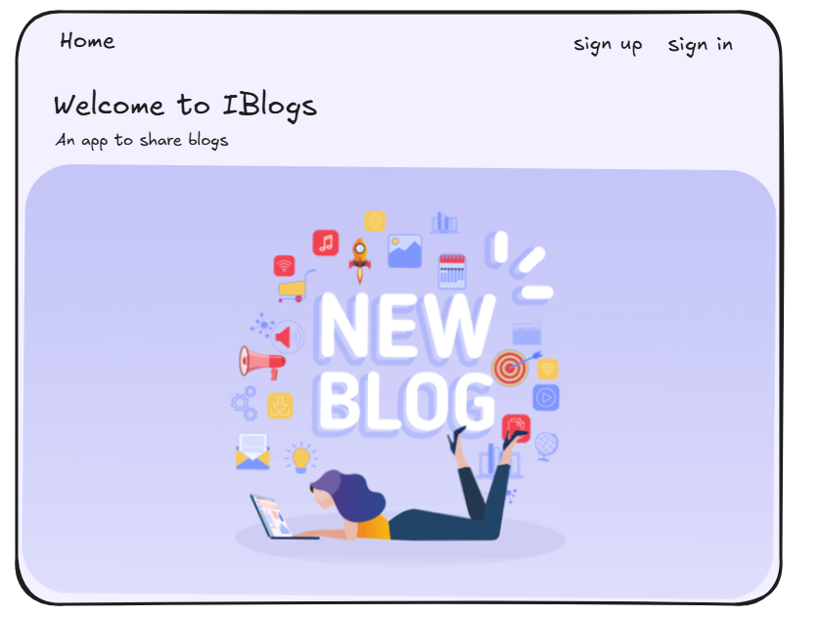

**Description :**

**The blog platform is a user-friendly hub where individuals can effortlessly create, manage, and share blog posts. Users have easy access to their personalized dashboard, enabling seamless navigation to view, delete ,edit and add blog content. The platform promotes community interaction, allowing users to explore each other's blogs fostering a supportive and inspiring environment for bloggers.**

**User stories :**

**1. As a User, I want to be able to sign up and sign in to my account, so I can access my blog dashboard.**

**2.As a User, I want an easy and consistent way to navigate through the site, whether I am signed in or not. I need to quickly access options to sign up, sign in, view my blogs or sign out, depending on my current status.**

**3. As a User, I need a dedicated page to view all my blogs , to easily manage and review what I have stored.**

**4. As a User, I want to easily find and click on an 'Add New blog' link, which takes me to a form for adding new blog.**

**5. As a User, after filling out the blog form, I want to submit it and receive confirmation that the item has been saved in my blogs.**

**6. As a User, I need the ability to edit and delete items in my blogs, allowing me full control over managing my stored items.**

**7. As a User, I am interested in viewing a list of all other app users, to foster a sense of community and interaction within the app.**

**8. As a User, I want the option to click on another user's profile and view all the items in their blogs, to find inspiration for my own blogs .**

**Pseudo code :**

* **Controllers folder :**

auth.js : Get and post sign-in , sign-up .

blogs.js : CRUD ( Create , Read , Update and delete Blogs ) using routers .

users.js : Get all the users in the app using routers .

* **Middleware folder :**

**isSignedIn.js : Check if the user signed in .**

**addUserToViews.js : To add users .**

* **Models folder :**

**user.js ( For Schemas ) :**

**blogsSchema : title , content , author , post , date .**

**userSchems : username , password , blogs [ blogsSchema ] .**

* **Public / stylesheet :**

**Style.css : for CSS design .**

* **Views folder :**

**index.ejs : to show to home page .**

1. **auth folder :**

**sign-in.ejs : Sign in form page .**

**sign-up.ejs : Sign up form page .**

1. **blogs folder :**

**edit.ejs : Editing form page .**

**new.ejs : Adding new item form page .**

**index.ejs : Seeing all the blogs that exist in the DB.**

**Show.ejs : Show page for each blog .**

1. **partials folder :**

**_navbar.ejs : navigation bar .**

1. **users folder :**

**index.ejs : show the list of all the users .**

**show.ejs : show each user blog ( profile ) .**

* **server.js : listening to the server and for requiring .**